- The ROV shall weigh less than or equal to 18 kilograms.
- The ROV’s size shall be able to fit within a 1 by 1 meter square hole.
- The ROV shall be constructed using corrosion-resistant materials.
- Requirement - The ROV shall maintain material integrity in temperatures ranging from 0°C to 40°C.
- The ROV’s center of gravity shall be on the centerline.
- The ROV shall not leave debris.
- The ROV’s attached items shall be secured.
- The Propellers shall be completely shrouded to IP-20 Standards.
- The ROV’s Mesh size shall be less than 12.5 millimeters.
- The ROV shall have no sharp edges or elements that could injure personally.
- The ROV shall be serviceable using basic hand tools.
- The ROV shall use standardized mounting patterns for components.
- The ROV shall have identifiable connection points. (For troubleshooting)
- The ROV shall use reusable fasteners when possible.
- The ROV shall have adequate ROV-side strain relief.
- The ROV’s pressure housings can withstand depth up to 7 meters

If Applicable:
The ROV’s Hydraulics shall utilize water.
The ROV’s Pneumatics shall utilize compressed air or inert gas.
The ROV’s pressure lines shall
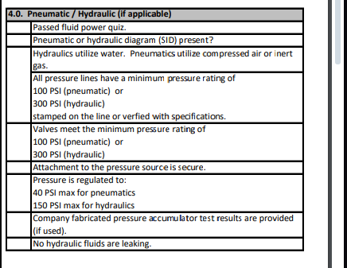
https://20693798.fs1.hubspotusercontent-na1.net/hubfs/20693798/2025%20Onsite%20Safety%20Inspection%20PIONEER%20Updated.pdf

Need to describe trade-offs and rationale for vehicle cost, size, and weight

